TEAMSTER NETWORK DESIGN

Name
Course
Date

Network design paradigm in Teamsters
To have a well-structured and secure network at Teamsters, various considerations should be considered depending on the information they provided concerning their business. Therefore before we get to the actual design, we must, first of all, give a brief explanation of our proposed network design that is in terms of the network topology that we will use in our plan, as well as a brief description of the items we have indicated on our shopping list to show why we need them. To start with, we have the following.
Router
This has been our first item on our list. The router will be connecting the computers and other peripheral devices to the internet web. It will mainly be used to dispatch information by choosing the best route for the data involved to travel through. As it does this, it also ensures the data involved is protected. For example, in Teamsters, the router will help make sure that the computers are connected to a local network so that the employees can share the files over the network; if the router is absent, the business data will not be directed to the desired place or point. For instance, if a user wants to print a document from a given computer, he will need the router to direct the document to the printer, not a scanner or any other computer. The choice of the router we have indicated for teamster in our shopping list is so far the best.
The switch
Though a switch is a router in itself, its operations are mainly on the data link layer of the OSI model. Therefore, the switch will be helpful in our design because it helps reduce network collisions that might occur. Teamster business has over 20 devices connected to the network, so there is a dire need to have it in our setup. Additionally, it reduces the collision by taking data packets being sent by matching the ports where the data is sent.
Network Repeater
This electronic device is designed to receive signals and amplify it before it becomes too feeble or corrupted. Repeaters work well on the physical layer. Remember, in Teamsters, there will be a tv set that will be located in the reception chances are, depending on the network performance, at one point, the signals will get weak, and the repeaters will be improving them.
Ethernet cable
This is what we intend to use to connect the computers for easier data sharing. We have preferred since the business needs rely too much on the internet and cat six is faster than cat five, and it reduces noise within the network or the cross talks.
Choice of network topology to feature in the design
By definition, network topology refers to how a given network is physically or logically arranged with clear indications on how the devices are configured and relate to each other. The design diagram that we will draw will majorly indicate two areas of our network design: Physical Topology, which will show how different computer nodes are linked to each other. This includes the location and the installation of the computer networks. In simple terms, it's the physical layout of workstations, cables as well as nodes orientation. Moreover, the design also shows the logical topology describing how data packets are supposed to move from one workstation to another.

Star and bus topology
Our design diagram includes two topologies that are Star and bus topology. From the information provided, teamsters have two severs that imply other computers must be connected to the servers to access data held at a central point. Star topology will be applicable in this case because any given node that will be requesting service must contact the server first to be permitted to get the data. In that case, also the switch will be the middleware of the nodes. It's also good to note that not all computers will have access to the server, to be interconnected in a bus. So what the switch will be doing is unicasting the messages, and it will do this through a switch table. This is important because unnecessary traffic on the network will be avoided. It's also important to note that this topology combination ensures security since the data does not necessarily need to pass through all nodes as in ring topology. Below is an illustration of a star topology.
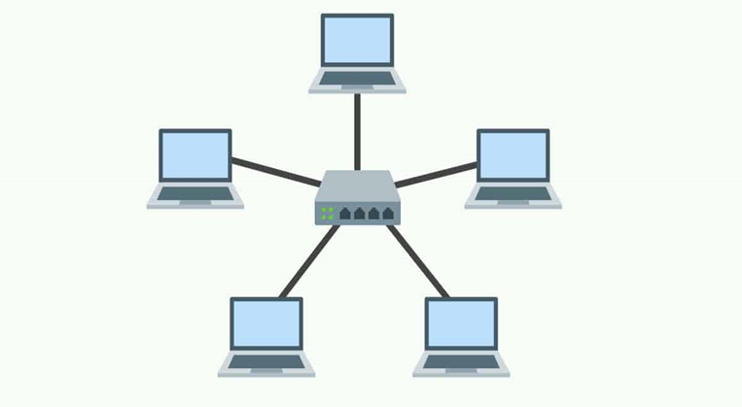
Equally, there is a need to consider a bus topology to reinforce the weaknesses of the star topology. We have seen that in our case, not all computers will be directly connected to the server. The bus topology will be suitable to connect the other devices that won't be connected to the server because it's oriented by a single cable that runs one end to the end of the network. This implies the data will also flow to the route of the cable in the same direction. Below is an illustration of a bus topology.

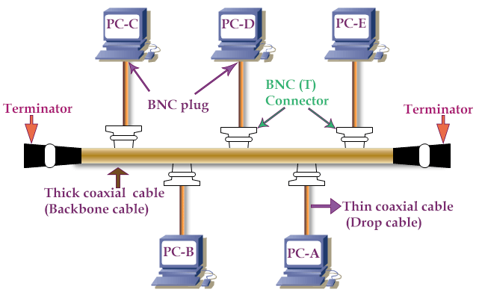

Whenever a workstation transmits data on this topology, all other workstations see the data over the cable. Still, only one workstation will accept that data if it was addressed to it. For instance, from the above diagram, if PC-B sends data to the PC-E, all other computers will see the data, but only E will accept because it was addressed to it. The router does this.

TV PC

TERMINATOR REPEATER

SWITCH
ROUTER
SERVER 2

SERVER 1 PRINTER
PC PC
PC

A shopping list for items required to set up the computer networks at
ITEM NUMBER | ITEM ESCRIPTION | QUANTITY | PRICE
Router | Speed: 1800Mbps, upload 800Mbps  Connectivity: 8 x Gigabit Ethernet, 2 x USB 3.0, 1 x M.2 SATA | one | $ 200
Ethernet cables | 150 meters roll CAT 6 | One roll | $ 30
Switch | Cisco Catalyst 2960X Gigabit Switch (2960X-48FPS-L) | 48-Port PoE+ (740W), 4 x Gigabit SFP | one | $1000
Repeater | G 4G GSM WCDMA LTE Indoor Outdoor Coverage Mobile Signal Amplifier Booster Band Selective Wireless RF Repeater | one | $1000
Crimping tool | Quality Crimping Tool For RJ45 RJ11 Cat7 Cat6A Cat5 Modular Plugs Metal Plier Crimper Combo Kit | one | $400
Rj45 connectors | FTP STP Shielded 8p8c RJ45 Cat6 Modular Plug Connector | 500 | $ 2
 |  | TOTALS | $ 2432

Advantages of this network design
This network setup is easier to manage from every point, it's easier to add a node or remove it, and it is durable and minimizes the length of the cable needed. However, it also has limitations associated with it, one of them being that it requires a network specialist if there are breakdowns. Finally, if the number of ports in the switch is limited, it limits network size.

Bibliography
Frangopoulos, Paraskevi, and Selim G. Akl. "Edge-disjoint spanning trees on the star network
with applications to fault tolerance." IEEE Transactions on Computers 45, no. 2 (1996): 174-185.
Meador, Brett. "A survey of computer network topology and analysis examples." Washington
University (2008).
Sal dana, Fernando, and Ignacio Barradas. "Control strategies in multigroup models: the case of
the star network topology." Bulletin of mathematical biology 80, no. 11 (2018): 2978-3001.

Meador, Brett. "A survey of computer network topology and analysis examples." Washington University (2008).
Frangopoulos, Paraskevi, and Selim G. Akl. "Edge-disjoint spanning trees on the star network with applications to fault tolerance." IEEE Transactions on Computers 45, no. 2 (1996): 174-185.
Sal dana, Fernando, and Ignacio Barradas. "Control strategies in multigroup models: the case of the star network topology." Bulletin of mathematical biology 80, no. 11 (2018): 2978-3001.

